Project Design Phase-II Technology Stack (Architecture & Stack)

Date | 11 February 2026
Team ID | LTVIP2026TMIDS54303
Project Name | Online Payment Fraud Detection using Machine Learning
Maximum Marks | 4 Marks

Technical Architecture:
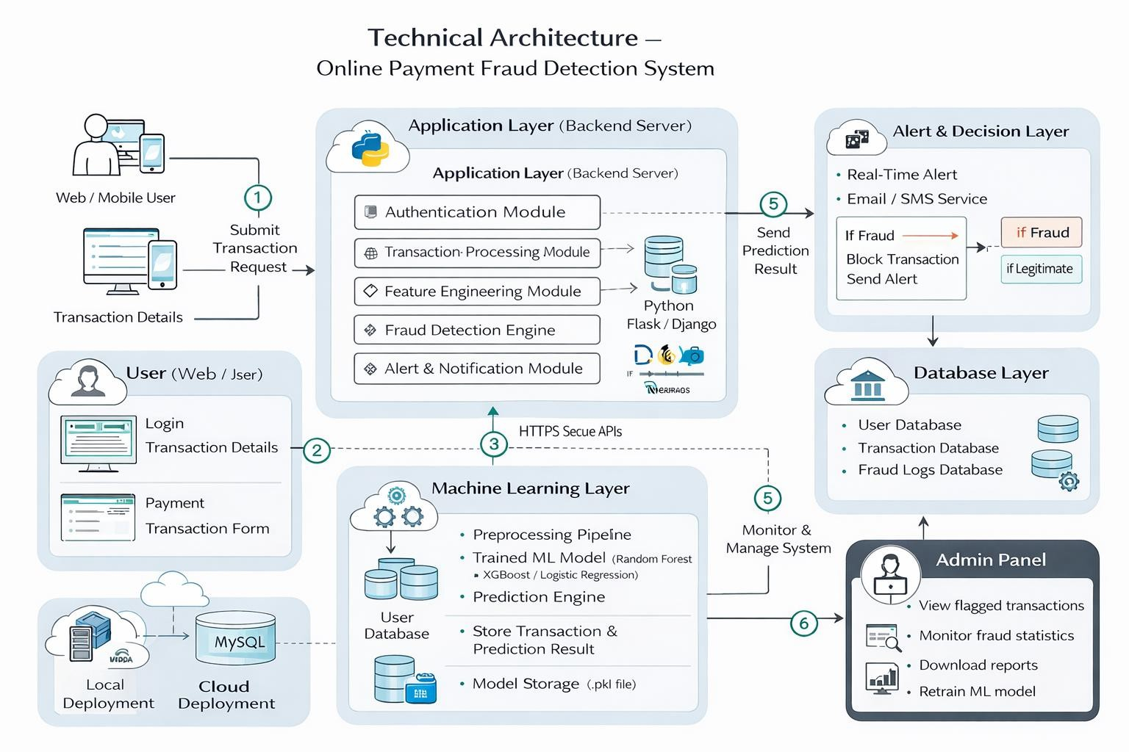

Table-1 : Components & Technologies:

S.No | Component | Description | Technology
1 | User Interface | Web-based interface for users and admin to perform transactions and view  fraud alerts | HTML, CSS,  JavaScript, Bootstrap  / React JS
2 | Application Logic-1 | Transaction processing and validation logic | Python (Flask / Django)

3 | Application Logic-2 | Fraud detection logic using trained ML model | Python (Scikit-learn, Pandas, NumPy)
4 | Database | Store user details, transaction history,  fraud logs | MySQL / PostgreSQL
5 | Cloud Database | Cloud-based storage for scalable  transaction data | AWS RDS / MongoDB Atlas
6 | File Storage | Storage of datasets, trained ML model (.pkl), reports | Local File System / AWS S3
7 | External API-1 | Payment gateway integration for  transaction validation | Razorpay API / Stripe API
8 | Machine Learning Model | Predict fraudulent vs legitimate  transactions | Random Forest / Logistic Regression /  XGBoost
9 | Infrastructure (Server  / Cloud) | Application deployment environment | Local Server (Windows/Linux), AWS EC2 / Heroku

Table-2: Application Characteristics:

S.No | Characteristics | Description | Technology
1 | Open-Source Frameworks | Frameworks used for backend, ML, and  frontend | Flask, Scikit-learn, Pandas, NumPy,  Bootstrap
2 | Security Implementations | Encryption, authentication, secure APIs, input validation | HTTPS, SHA-256  Password Hashing, JWT Authentication, OTP Verification
3 | Scalable Architecture | 3-Tier Architecture  (UI → Application → Database) supporting future microservices  scaling | Flask (API Layer), MySQL, AWS EC2
4 | Availability | System available 24/7 with minimal downtime using cloud deployment | AWS EC2 / Load Balancer
5 | Performance | Real-time fraud detection with millisecond-level prediction, optimized  queries | Scikit-learn optimized model, Indexed Database, Caching

6 | Data Privacy | Secure handling of user financial data | Data Encryption, Secure APIs, Access Control
7 | Maintainability | Easy model retraining and  system updates | Modular Python Code, Version  Control (Git)

